**NORTH RYDE SOCCER CLUB goes BLING!**

**By Peter Rolls**

27 July 2013

**BOLLYWOOD EAT YOUR HEART OUT!!!**

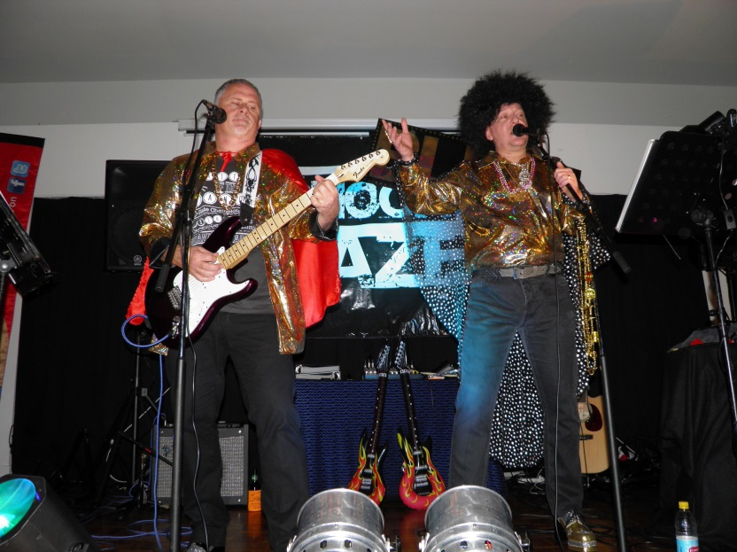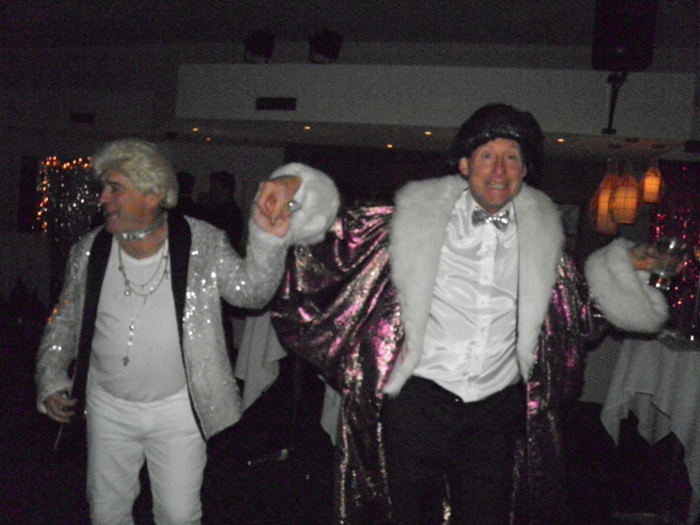**OUR SOCCER SOCIALITES TURN IT ON IN STYLE FOR OUR 60TH ANNIVERSARY!!!**

***BLING HIGHLIGHTS:***

* **LIBERACE and his CHAUFFEUR make a GRAND ENTRANCE with “THE IMPOSSIBLE DREAM”!**
* **SHOCK DAZE MUSIC BEDAZZLES 93 BLINGERS with SOUNDS from… “GET LUCKY” by DAFT PUNK to “EAGLE ROCK” by DADDY COOL!**
* **BARRY ALCHIN’S OVER 45/2 TABLE TAKES THE FAB FEDELES TRIVIA PRIZE! (U6 YELLOW RUNNERS UP.)**
* **DAVE ANDERSON’S U11/2 TABLE WINS BEST DRESSED TABLE! (AND LAST PLACE IN TRIVIA!!)**
* **MARK MILNE WAS ALL CLASS IN BEING WINNER OF BEST DRESSED INDIVIDUAL! (DUTCHY RUNNER UP).**
* **“IM TOO SEXY” COMPETITION WON BY COUPLE ON DAVE ANDERSON’S TABLE! (What an AWESOME table!!)**

***BLING MOMENTS:***

* Opening waltzes by Liberace and Chauffeur then joined by Dave and Rachel, Barry and Karen and Phil and Lou.
* Tony Zdilar and Scott Wightman (Shock Daze) BLING performance and also helped dress the room with Jillian and Peter Rolls, Debbie and Paul Uhrig so the scene was set to feel like we were actually in Bollywood!
* Dave Anderson welcomed all on behalf of the NRSC and opened the night with grand aplomb covering our team’s performances this season. Especially recognizing the mighty 3rd placed inaugural Over 45/2 by mentioning how they were probably already born when the club was created! (To raucous laughter!!)
* John Spencer sponsored the “I’m Too Sexy” competition with a night’s accommodation at the Harbourview Hotel at North Sydney. The winning couple will get good value out of that but hope they don’t damaged the walls!
* Callaghan Street Liquor Store (Tony and Arlaine) generous supporter and sponsor over the 6 years of the social night events with prizes of wine, beer, glasses, hats, footy’s, T-shirts and cooler bags.
* Kick Start provided two very well received vouchers for soccer training camps.
* Fedeles Pizza Restaurant panned in with 10 x $20 vouchers (to Bazza’s delight!).
* Jillian Rolls (Innovations sponsor with DVD’s) did a wonderful job of coordinating the event with allocating tables and collecting money to ensure an enjoyable night was had by all.
* Margie, Jillian, Debbie, Belinda and Richard Quan did a splendid job of marking and tallying the Trivia questions.
* Mark Simpson thanked sponsors and also provided a wrap up of the season.
* 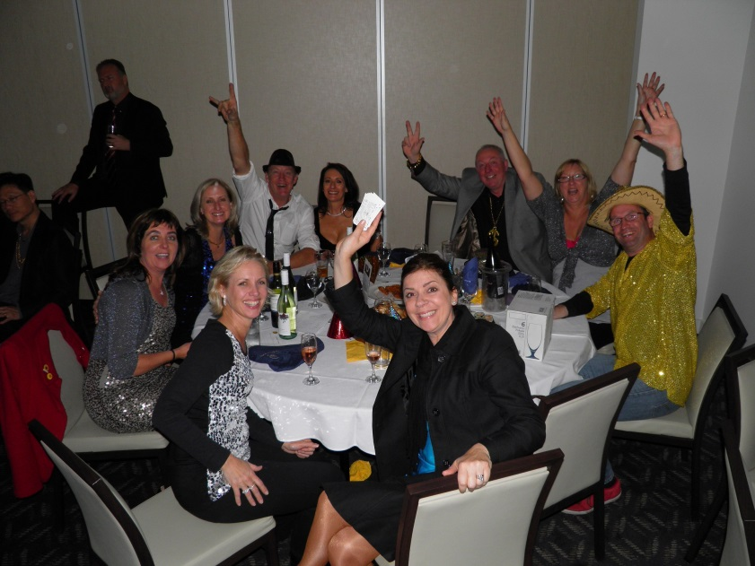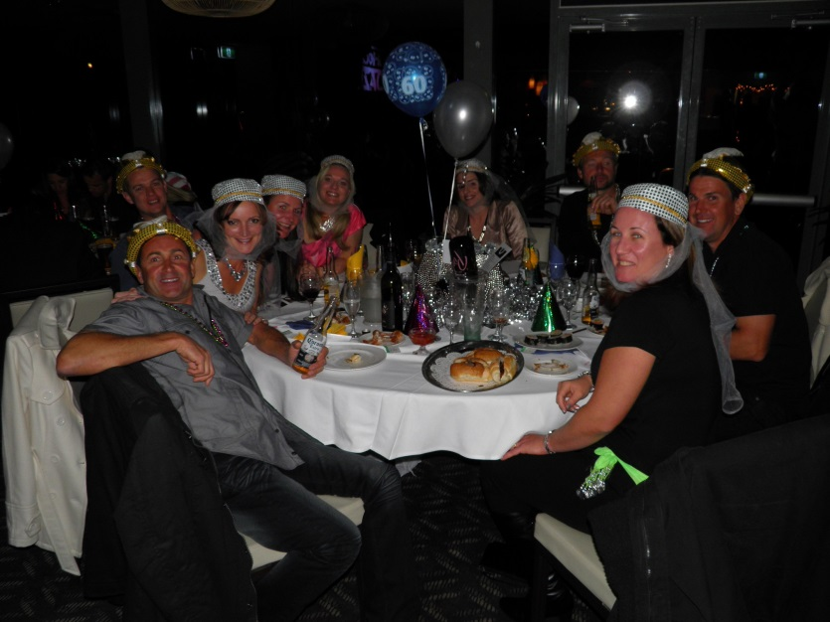Shock Daze rocked the club til midnight.

**Trivia Winners – Barry Alchin’s O45/2**

**Best Dressed Table – Dave Anderson’s U11/2**

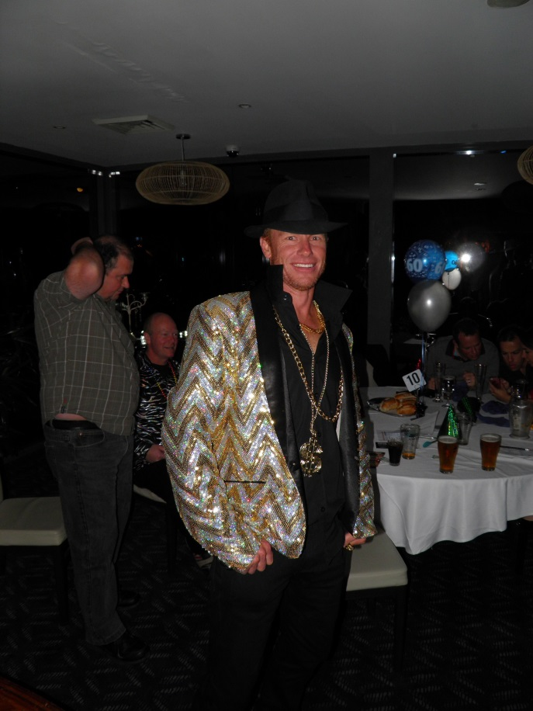

**Best Dressed Individual – Mark Milne**

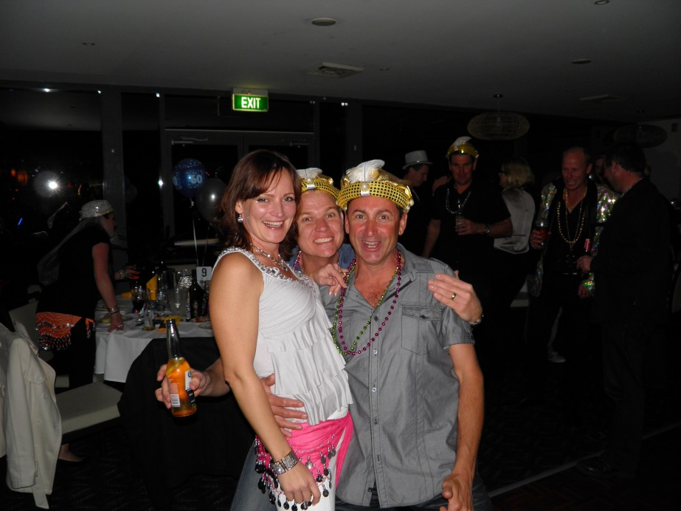

**“I’m Too Sexy” dance winners and Ando**

